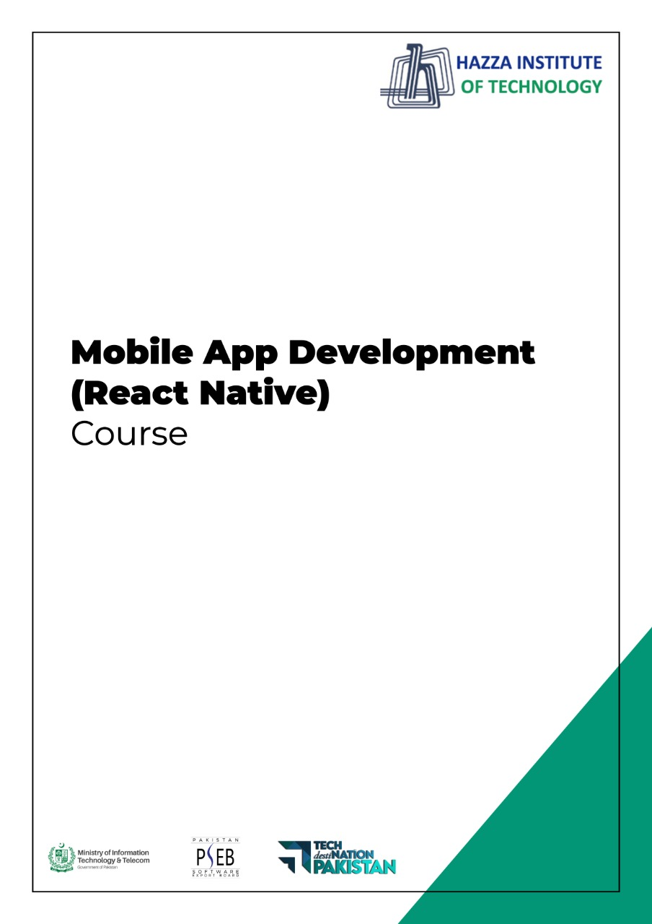
(Flutter)
Flutter Lab 10

Total Time:
3 hours ( session-2)

Pre-Lab Activities:
  - Basics of Flutter UI Widgets

Learning Outcomes:
  - Learn TextField
  - Learn TextFormField
  - Learn Form Validation
  - Learn Fluttertoast

Student Activities:
  - Complete the pre-lab activities
  - Practicing Basic Widgets

Lab Tasks 10A:
- Design the UI accoriding to below given image.
- Create 2 TextFields
- Create 4 ElevatedButtons in a Row
- Understand the use of TextEditingController

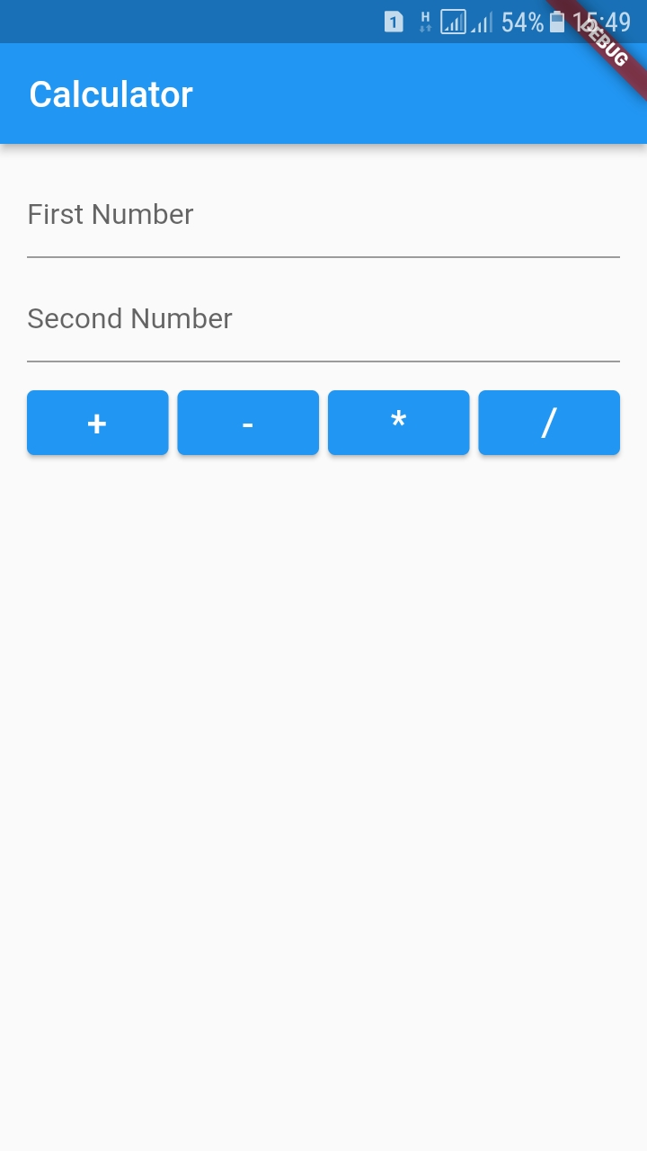

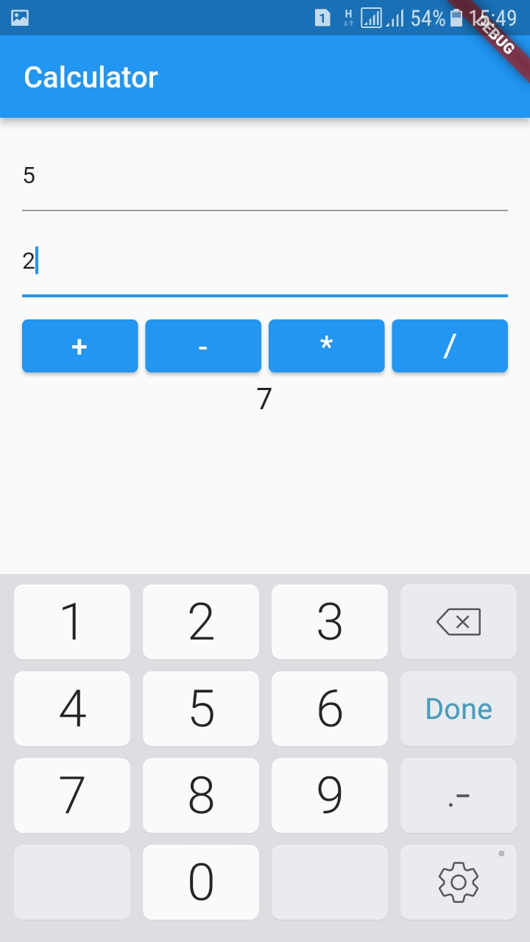

Lab Solutions:

LAB 10A :
CODE:
main.dart
import 'package:flutter/material.dart';
import 'package:textfield_pseb_bridge_9c/screens/home_screen.dart';

void main() {
runApp(const MyApp());
}

class MyApp extends StatelessWidget {
const MyApp({Key? key}) : super(key: key);

// This widget is the root of your application.
@override
Widget build(BuildContext context) {
return MaterialApp(
title: 'Flutter Demo',
theme: ThemeData(
primarySwatch: Colors.blue,
),
home: const HomeScreen(),
);
}
}

Home_screen.dart
import 'package:flutter/material.dart';
import 'package:fluttertoast/fluttertoast.dart';

class HomeScreen extends StatefulWidget {
const HomeScreen({Key? key}) : super(key: key);

@override
State<HomeScreen> createState() => _HomeScreenState();
}

class _HomeScreenState extends State<HomeScreen> {

var firstController = TextEditingController();
var secondController = TextEditingController();
var result = '';

@override
Widget build(BuildContext context) {
return Scaffold(
appBar: AppBar(
title: const Text('Calculator'),
),
body: Padding(
padding: const EdgeInsets.all(15.0),
child: SingleChildScrollView(
child: Column(
children: [

TextField(
controller: firstController,
keyboardType: TextInputType.number,
decoration: const InputDecoration(
hintText: 'First Number'
),
),
const SizedBox(height: 10,),

TextField(
controller: secondController,
keyboardType: TextInputType.number,
decoration: const InputDecoration(
hintText: 'Second Number'
),
),
const SizedBox(height: 10,),

Row(
children: [
Expanded(child: ElevatedButton(
onPressed: (){
calculate('+');

},
child: const Text('+', style: TextStyle(fontSize: 20),),
)),
const SizedBox(width: 5,),
Expanded(child: ElevatedButton(
onPressed: (){
calculate('-');
},
child: const Text('-', style: TextStyle(fontSize: 20),),
)),
const SizedBox(width: 5,),

Expanded(child: ElevatedButton(
onPressed: (){
calculate('*');

},
child: const Text('*', style: TextStyle(fontSize: 20),),
)),
const SizedBox(width: 5,),

Expanded(child: ElevatedButton(
onPressed: (){
calculate('/');

},
child: const Text('/', style: TextStyle(fontSize: 20),),
)),

],

),
Text(result, style: const TextStyle(fontSize: 20),),

],
),
),
),
);
}

calculate( String opr ){

String first = firstController.text.trim();
String second = secondController.text.trim();

if( first.isEmpty || second.isEmpty){
Fluttertoast.showToast(msg: 'Please provide both numbers');
}
else{
int res = 0;
switch(opr){
case '+':
res = int.parse(first) + int.parse(second);
break;
case '-':
res = int.parse(first) - int.parse(second);
break;
case '*':
res = int.parse(first) * int.parse(second);
break;
case '/':
res = int.parse(first) ~/ int.parse(second);
break;
}

setState((){
result = '$res';
});
}
}
}
Complete source code:
https://github.com/abidroid/textfield_pseb_bridge_9c

Lab 10.B

- Create a DMC app.
- Design the UI accoriding to below given image
- Create Form with TextFormFields
- Apply Validation

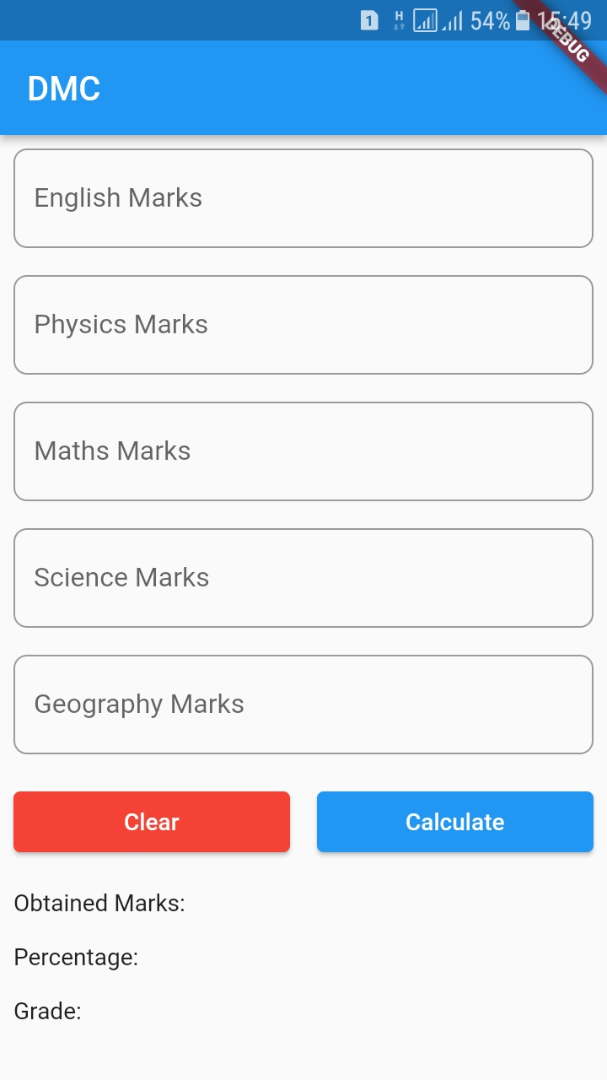
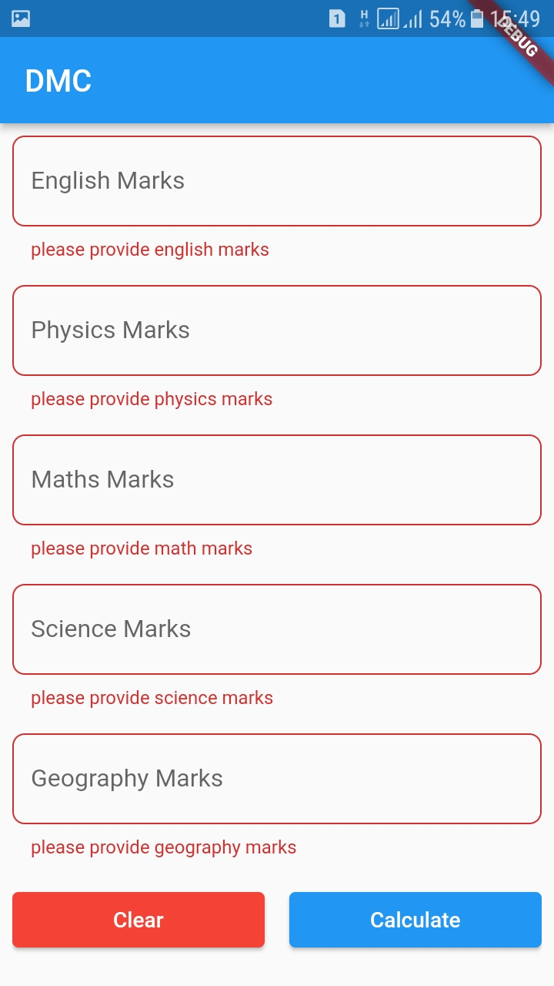

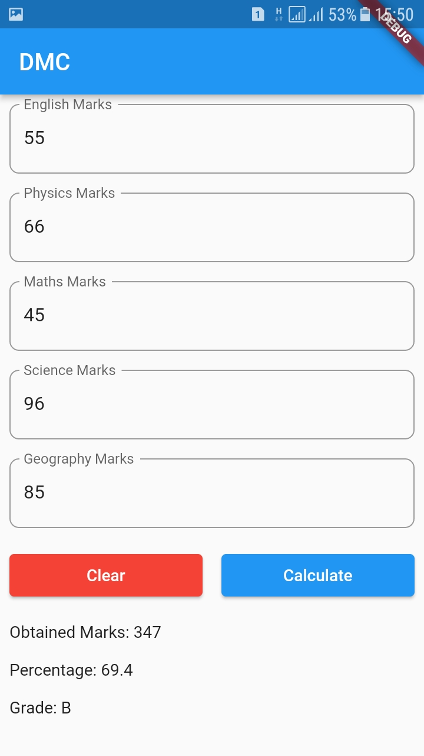

Lab 10B Solution
Main.dart
import 'package:flutter/material.dart';
import 'package:text_form_field_validation_pseb_bridge_9d/screens/dmc.dart';

void main() {
runApp(const MyApp());
}

class MyApp extends StatelessWidget {
const MyApp({Key? key}) : super(key: key);

// This widget is the root of your application.
@override
Widget build(BuildContext context) {
return MaterialApp(
title: 'Flutter Demo',
theme: ThemeData(
primarySwatch: Colors.blue,
),
home: const Dmc(),
);
}
}

Dmc.dart
import 'package:flutter/material.dart';

class Dmc extends StatefulWidget {
const Dmc({Key? key}) : super(key: key);

@override
State<Dmc> createState() => _DmcState();
}

class _DmcState extends State<Dmc> {

var formKey = GlobalKey<FormState>();
late int eng, phy, math, sci, geo;
var obtMarks = '';
var percentage = '';
var grade = '';

@override
Widget build(BuildContext context) {
return Scaffold(
appBar: AppBar(
title: const Text('DMC'),
),
body: Padding(
padding: const EdgeInsets.all(8.0),
child: Form(
key: formKey,
child: SingleChildScrollView(
child: Column(
crossAxisAlignment: CrossAxisAlignment.start,
children: [
TextFormField(
keyboardType: TextInputType.number,
decoration: InputDecoration(
hintText: 'English',
labelText: 'English Marks',
border: OutlineInputBorder(
borderRadius: BorderRadius.circular(8.0),
)),
validator: (text) {
if (text == null || text.isEmpty) {
return 'please provide english marks';
} else {
eng = int.parse(text);
return null;
}
},
),
const SizedBox(
height: 16,
),
TextFormField(
keyboardType: TextInputType.number,
decoration: InputDecoration(
hintText: 'Physics',
labelText: 'Physics Marks',
border: OutlineInputBorder(
borderRadius: BorderRadius.circular(8.0),
)),
validator: (text) {
if (text == null || text.isEmpty) {
return 'please provide physics marks';
} else {
phy = int.parse(text);
return null;
}
},
),
const SizedBox(
height: 16,
),
TextFormField(
keyboardType: TextInputType.number,
decoration: InputDecoration(
hintText: 'Maths',
labelText: 'Maths Marks',
border: OutlineInputBorder(
borderRadius: BorderRadius.circular(8.0),
)),
validator: (text) {
if (text == null || text.isEmpty) {
return 'please provide math marks';
} else {
math = int.parse(text);
return null;
}
},
),
const SizedBox(
height: 16,
),
TextFormField(
keyboardType: TextInputType.number,
decoration: InputDecoration(
hintText: 'Science',
labelText: 'Science Marks',
border: OutlineInputBorder(
borderRadius: BorderRadius.circular(8.0),
)),
validator: (text) {
if (text == null || text.isEmpty) {
return 'please provide science marks';
} else {
sci = int.parse(text);
return null;
}
},
),
const SizedBox(
height: 16,
),
TextFormField(
keyboardType: TextInputType.number,
decoration: InputDecoration(
hintText: 'Geography',
labelText: 'Geography Marks',
border: OutlineInputBorder(
borderRadius: BorderRadius.circular(8.0),
)),
validator: (text) {
if (text == null || text.isEmpty) {
return 'please provide geography marks';
} else {
geo = int.parse(text);
return null;
}
},
),
const SizedBox(
height: 16,
),
Row(
children: [
Expanded(
child: ElevatedButton(
style: ElevatedButton.styleFrom(
primary: Colors.red,
),
onPressed: () {
formKey.currentState!.reset();
obtMarks = '';
percentage = '';
grade = '';
setState(() {

});
},
child: const Text('Clear'))),
const SizedBox(
width: 16,
),
Expanded(
child: ElevatedButton(
onPressed: () {
if (formKey.currentState!.validate()) {
int obt = eng + phy + math + sci + geo;
double per = obt * 100 / 500;

if (per >= 80) {
grade = 'A1';
} else if (per >= 70) {
grade = 'A';
} else if (per >= 60) {
grade = 'B';
} else if (per >= 40) {
grade = 'C';
} else {
grade = 'Fail';
}

setState(() {
obtMarks = obt.toString();
percentage = per.toString();
});
}
},
child: const Text('Calculate'))),
],
),
const SizedBox(
height: 16,
),
Text('Obtained Marks: $obtMarks'),
const SizedBox(
height: 16,
),
Text('Percentage: $percentage'),
const SizedBox(
height: 16,
),
Text('Grade: $grade')
],
),
),
),
),
);
}
}

Complete source code:
https://github.com/abidroid/text_form_field_validation_pseb_bridge_9d

